IoT Based Solar-Powered Smart Home Automation System

*A design Lab Report*

*Submitted by*

**Hritik Kumar 1901EE26**



**DEPARTMENT OF ELECTRICAL ENGINEERING INDIAN INSTITUTE OF TECHNOLOGY PATNA.**

**April** 2022

# ABSTRACT

This report presents an IoT-based implementation of the Smart Home Management system, which deals with the smart energy management system, smart health care system, smart ventilation system, along with smart people management. Sensors are present in the entrance gate, corridor, living room, and kitchen and they can be extended to large-scale implementation.

The power supply to the hardware system is given by a battery (12 V.) using a voltage regulator.

The hardware model is developed with a proper sensor control scheme such as the delay for

opening and closing of doors, Fan control, Light Bulb, etc.

The power requirement for the smart home system is met from the solar fixed on the rooftop

at night the power is supplied from the battery.

# TABLE OF CONTENTS

Introduction: 4

Components used in Smart Home Management system: 5

Arduino: 5

Voltage Regulator: 5

Sensors: 5

LCD 6

PMDC Motor & Servo Motor 6

Hardware Implementation: 7

Arduino Code: 8

Living Room: 8

Kitchen & Corridor 9

Results: 10

Flowchart 11

Block Diagram: 12

Conclusion: 13

References: 13

# INTRODUCTION

Internet of Things is the networking of physical objects that contain electronics embedded within their architecture to communicate and sense interactions amongst each other or the external environment.

With the increase in the popularity of the internet, in upcoming years IoT-based technology will offer advanced levels of services and practically changes the way people lead their daily lives. Advancements in medicine, power, agriculture, smart cities, and smart homes are just a very few of the categorical examples where IoT is strongly established.

A smart home is a home that can do all kinds of automated functions, which allow homeowners to control appliances, thermostats, lights, and other devices such as washing machines, fridges, garage door opening) remotely using a smartphone through an internet connection.

With smart home we can maximize the home security, the user will be able to control the arming and disarming of the alarm, as well as edit specific settings of the alarm, such as the key code.

The user would be able to control the heating and cooling of the home. Alarm clock functionality can be a useful feature in the smart home management system.

### Components used in Smart Home Management System:

* Arduino UNO: For the Smart Home system, Arduino UNO acts as a microcontroller, which uses ATMEGA 328P. It monitors and controls all the functioning of the sensors according to the given command, which is encoded using Arduino IDE.
* Voltage Regulator: LM7805 is used as the voltage regulator to supply voltage at a constant value of 5V to all sensors and Arduino. It is a linear voltage regulator. Its optimal condition of operation are:
* Input Voltage: Minimum 7V, Maximum 25V
* Output Current: 1.5A
* Optimal Junction Temperature: 0-125 C

For countering the problem of the heat generated during the operation of the regulator we use heat sinks, which increase the surface area for the heat dissipation, by the regulator.

* Sensors (All sensors are operated at 5V Dc):
* DHT 11 => Digital Humidity and Temperature. Fig:[4] and Fig:[6]

It is used for checking the humidity and temperature in the internal atmosphere. For example, let’s say that the temperature of the room is greater than a threshold for operating the Fan or an AC, all cooling systems in the room will starts automatically with one signal from the Arduino. Similarly, if the temperature is lower than a threshold limit, It will trigger the heating system in the house.

* MQ2 and Flame Sensor:

It is a smoke sensor. It is used in the kitchen for detecting the leakage of the LPG gas in the kitchen, if there is any leakage, it will warn the owner of the house through the wireless communication modules like the GSM module.

Let’s say we use MQ2 along with Flame sensor, together they will warn the user if there is any fire in the house or fire is just started.

* Infrared Sensors fig[3], fig[0]: It is used for opening and closing the doors, and counting the number of individuals present in the room. For this two IR sensor modules are used one is placed outside the house near the gate such that it will detect the person entering in house, and another one is placed inside the house near the gate such that it will sense the person exiting the house. Following it, a signal sent from the sensor to Arduino will Open the door accordingly and count the number of individuals present in the room.

Exiting

Fig 0: Shows the layout design for counting the number of persons present in the room.

Outside House

IR - 1

IR - 2

Inside House

Entering

* PIR => Passive Infrared

It is used to detect the motion in the corridor of the house. It can be used to light up the bulbs in the corridor or inside the room or we can also use it to detect an intruder in the house when the owner is not present in the house, and it will send a signal to Arduino, and Arduino will use GSM module to send an alert signal to the owner.

* LM35 and Pulse Rate Sensor. Fig: [5]

Both are used as health scanning systems in the living room. LM35 can measure the body temperature, instead of using LM35, we can use an IR temperature sensor for better accuracy of the human body temperature.

* LCD

It is used to display all the monitoring data such as pulse rate, body temperature, atmospheric temperature and humidity, individual count in the room, etc.

* PMDC & Servo Motor:

The PMDC (Permanent Magnet Direct Current Motor) is used for the fan inside the kitchen and the Living Room and is controlled by the logic implemented inside the code of Arduino, i.e. if there is any leakage in the kitchen, the MQ2 sensor will send the signal to Arduino and correspondingly Arduino will warn the owner and it will start the fan of the Kitchen, similarly for the living room, if the temperature is above the threshold it Arduino will start the fan.

In the case of the Servo motor, it is used for opening and closing the doors. As servomotors rotation can be controlled using Arduino.

# HARDWARE IMPLEMENTATION

Fig: 1 is the final implementation of the IoT-based Smart Home Automation System, i.e. comprising all sensors, PMDC motor, Servo Motor, and Regulator-based supply.

Fig: 2 is showing all the internal circuit arrangements of the smart home automation system, which looks a bit entangled, but in the future, we can use wireless networks, for the transfer of the sensor data, to the main server of the network and the automation will work accordingly.

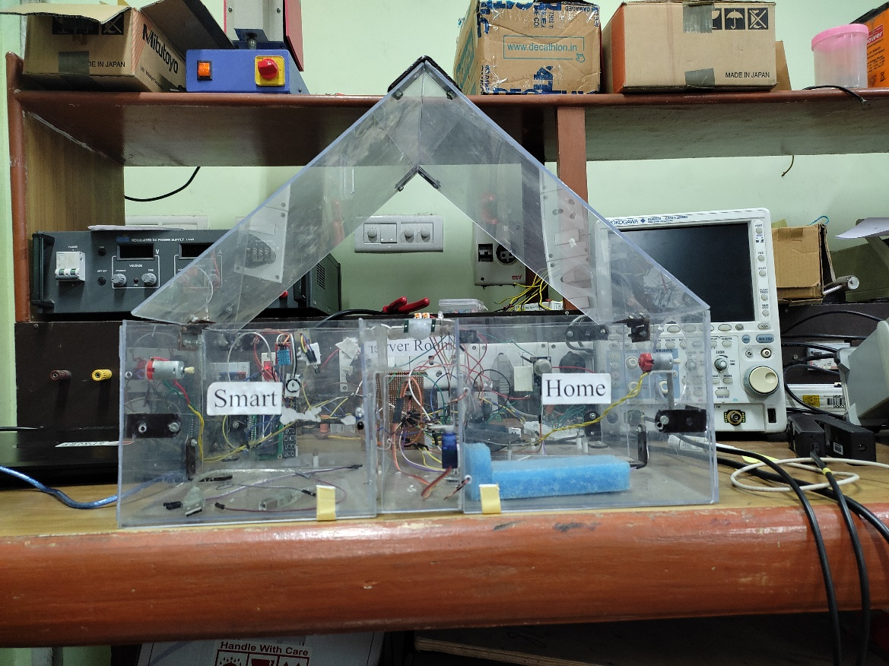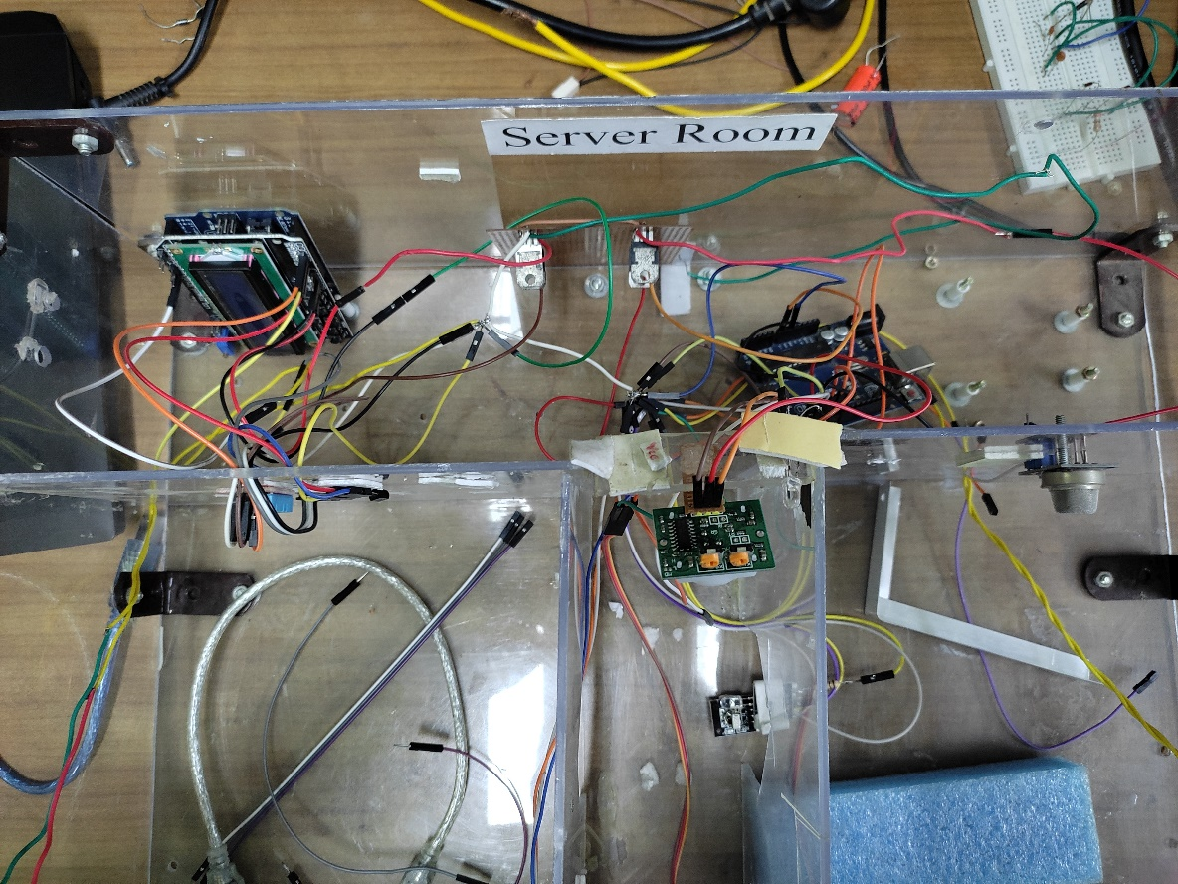

Fig: 1 Complete implementation of the Smart Home

Fig: 2 Internal Circuits.

# RESULTS

Fig: 5 Reading pulse on the LCD

Fig: 3 Representing number of individuals present in the house.

Fig: 4 Reading humidity on the LCD

Fig: 6 Reading room temperature on the LCD

# ARDUINO CODE **FOR LIVING ROOM**

#include <dht.h>

#include <LiquidCrystal.h>

const int rs = 8, en = 9, d4 = 4, d5 = 5, d6 = 6, d7 = 7;

LiquidCrystal lcd(rs, en, d4, d5, d6, d7);

dht DHT;

int Pulse = A2;

int LM = A1;

int humdTY = A3;

int fan2 = 13;

void setup(){

Serial.begin(9600);

pinMode(Pulse,INPUT);

pinMode(LM,INPUT);

pinMode(humdTY ,INPUT);

lcd.begin(16,2);

}

void loop(){

int lm = analogRead(LM);

int chk = DHT.read11(humdTY);

int pulse = analogRead(Pulse);

//fan2

if(DHT.temperature > 32){

analogWrite(fan2,1023);

}

else if(DHT.temperature >= 23 && DHT.temperature < 32){

analogWrite(fan2,300);

}

//Lm35 Temperature Sensor

lcd.clear();

lcd.setCursor(0,0);

lcd.print("Body Temperature");

lcd.setCursor(0,1);

lcd.print(0.48828125*lm);

delay(2000);

//DHT (Temperature)

lcd.clear();

lcd.setCursor(0,0);

lcd.print("Room Temperature");

lcd.setCursor(0,1);

lcd.print(DHT.temperature);

delay(2000);

//DHT (Humidity)

lcd.clear();

lcd.setCursor(0,0);

lcd.print("Humidity");

lcd.setCursor(0,1);

lcd.print(DHT.humidity);

delay(2000);

// Pulse Sensor

lcd.clear();

lcd.setCursor(0,0);

lcd.print("Pulse");

lcd.setCursor(0,1);

lcd.print(pulse);

delay(2000)

# ARDUINO CODE **FOR Kitchen and Corridor**

#include<Servo.h>

#include <dht.h>

Servo motor;

dht DHT;

//sensor and motor pins

int p=90;

int PIR = 2;

int irPin2=3;

int irPin1=4;

int ServoMotor = 5;

int LED = 6;

int fan1 = 7;

int MQ = A2;

//Mq2 threshold

int sensorThres = 400;

// bidirectional counter variable

int count=0;

void setup(){

Serial.begin(9600);

pinMode(irPin1,INPUT);

pinMode(irPin2,INPUT);

pinMode(PIR,INPUT);

pinMode(MQ,INPUT);

motor.attach(ServoMotor);

motor.write(0);

}

void loop(){

int in_val = digitalRead(irPin2);

int out_val = digitalRead(irPin1);

delay(500);

if (in_val == LOW){

count++;

Serial.println((String)"count in room : " + count);

for (p=0;p<90;p++){

motor.write(p);}

delay(1000);

for (p=90;p>0;p--){

motor.write(p);}

}

if (out_val == LOW){

count--;

Serial.println((String)"count in room : " + count);

for (p=0;p<90;p++){

motor.write(p);}

delay(1000);

for (p=90;p>0;p--){

motor.write(p);}

}

if (count <= 0){

Serial.println((String)"Count in Room : " + count);

delay(1000);

}

//Smoke

int smkAlt = 0;

if(analogRead(MQ) > sensorThres){

analogWrite(fan1,1023);

smkAlt = 1;

}

if(smkAlt == 1){

//Serial.println((String)"Gas Leakage in Kitchen! Alert!");

}

//Light bulb control in corridor.

int alert = 0;

if(digitalRead(PIR) == 1){

digitalWrite(LED,HIGH);

alert = 1;

}

else{

digitalWrite(LED,LOW);

}

if(count <= 0 && alert == 1){

//Serial.println((String)"Intruder! Alert");

## **Flow Chart**

Start

Flow Chart of Methodology used in the IoT-based Smart Home Automation System includes their systematic organization and organization and coordination at different stages.

N

Y

End

Communication Through IoT

Automation

Decision

Arduino

Input Data from Sensors

## **Block Diagram**



FAN

LAPTOP

(Arduino IDE)

Microcontroller

(Arduino IDE)

+

LCD



Regulator

PIR

DHT11

LM35

MQ2

Pulse

Regulator

LM7805

BATTERY

PV

Panel

Block Diagram of Overall Circuit for implementation.

# Conclusion

This report represents the implementation of the Smart Home automation system using the IoT principle. It ensures security, or any issue by alerting the owner, using the GSM module. It proposed green energy usage (Solar Panel), further, with the introduction of the concept of the smart grid system, we can directly integrate our IoT-based smart home system into the smart grids.

In that case, we will be able to supply unused power that is generated by the solar panels to the grid during the day, and during the night we will use the power from the grid, which will reduce the electricity bill of the owner.

Further, we can also introduce an AI model in the IoT system, for facial recognition system for entering the house, making the house a fully automated system by a computer brain.

**References**

* Nitika, S. Kumari, V. Kumar, and R. K. Behera, "Solar Powered Smart Home Design with IoT," 2020 IEEE-HYDCON, 2020, pp. 1-8, DOI: 10.1109/HYDCON48903.2020.9242901.
* C. Tipantuña and X. Hesselbach, "IoT-Enabled Proposal for Adaptive Self-Powered Renewable Energy Management in Home Systems," in IEEE Access, vol. 9, pp. 64808-64827, 2021, DOI: 10.1109/ACCESS.2021.30736